LMS Data Baseball Cap Sports Hats for Men and Women,%100 Cotton with Metal Adjustment Clips, Stylish, Comfortable and Breathable Outdoor Sports Hats, Sun Protection.
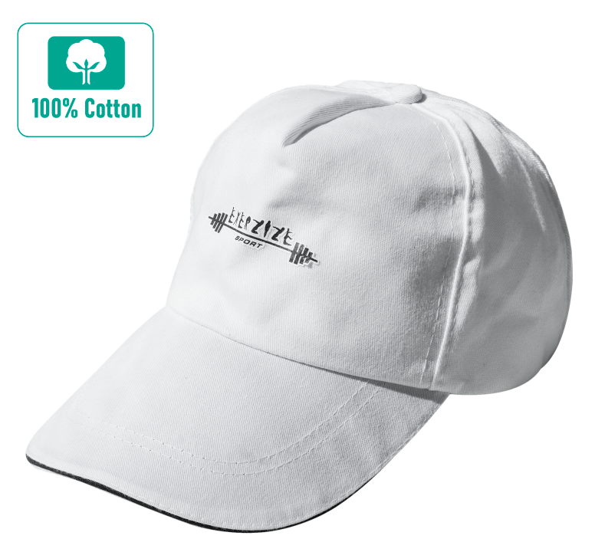
- PERFECT FIT | Adjustable metal buckle back closure, great fit for most head sizes ensure comfort at all times. Reinforced Professionally Hemming-Stitch, lightweight but durable makes baseball cap can ensure long time use.
- QUALITY & STURDY | High quality materials and craftsmanship, lightweight and breathable, %100 Cotton makes you feel cool and comfortable. Sweat-absorbent with the sweatband. Large shield protects you perfectly from sun.
- 100% Cotton
- Hand Wash Only
- Fastening: Buckle
- Baseball
- Stretch

- Part number: BB-HAT-WHT

